MINOR PROJECT REPORT
On

‘HAND GESTURE CONTROLLED WHEELCHAIR’

BACHELOR OF TECHNOLOGY

In
ELECTRONICS AND COMMUNICATION ENGINEERING

Submitted by:

JAGRASPALLI AFREEN TAJ 21011A0418
KASOJU AKHILA 22015A0407
RAVULA SAI PREETHAM 21011A0445
MOHAMMED FAIZ UR RAHMAN 21011A0460

Under The Esteemed Guidance of

Dr. P Chandrasekhar Reddy

Senior Professor

Department of ECE, JNTUH UCESTH

Department of Electronics and Communication Engineering

JAWAHARLAL NEHRU TECHNOLOGICAL UNIVERSITY HYDERABAD UNIVERSITY COLLEGE OF ENGINEERING, SCIENCE AND TECHNOLOGY HYDERABAD
Autonomous Kukatpally-Hyderabad-500085
2023-24

JAWAHARLAL NEHRU TECHNOLOGICAL UNIVERSITY HYDERABAD UNIVERSITY COLLEGE OF ENGINEERING, SCIENCE AND TECHNOLOGY HYDERABAD
Autonomous Kukatpally-Hyderabad-500085

DEPARTMENT OF ELECTRONICS AND COMMUNICATION ENGINEERING

DECLARATION OF THE CANDIDATE

We hereby declare the major project entitle “HAND GESTURE CONTROLLED WHEELCHAIR” is a bonafide record work done and submitted under the esteemed guidance of DR. P CHANDRASEKHAR REDDY, Senior Professor of ECE department, JNTUHCEH, in partial fulfilment of the requirements for the award of the degree of Bachelor of Technology (Regular) in Electronics and Communication Engineering during the academic year 2023-2024. This record is a bonafide work carried out by us and the results kept in the major project have not been reproduced or copied. The results in the project have not been submitted to any other university for the award degree or diploma.

JAGRASPALLI AFREEN TAJ (21011A0418)
KASOJU AKHILA (22015A0407)
RAVULA SAI PREETHAM (21011A0445)
MOHAMMED FAIZ UR RAHMAN (21011A0460)

JAWAHARLAL NEHRU TECHNOLOGICAL UNIVERSITY HYDERABAD UNIVERSITY COLLEGE OF ENGINEERING, SCIENCE AND TECHNOLOGY HYDERABAD

Autonomous Kukatpally-Hyderabad-500085
DEPARTMENT OF ELECTRONICS AND COMMUNICATION ENGINEERING

CERTIFICATE

This is to certify that the Project Report entitled “HAND GESTURE CONTROLLED WHEELCHAIR” being submitted by JAGRASPALLI AFREEN TAJ, KASOJU AKHILA, RAVULA SAI PREETHAM, MOHAMMED FAIZ UR RAHMAN in partial fulfilment for the award of the Degree of Bachelor of Technology in Electronics and Communication Engineering from Jawaharlal Nehru Technological University Hyderabad College of Engineering Hyderabad is a bona fide work carried out under my guidance and supervision. The results are verified and found satisfactory. The results embodied in this project report have not been submitted to any other University or Institute for the award of any Degree or Diploma.

Project Supervisor

Dr. P. Chandrasekhar Reddy
Senior Professor Department of ECE
JNTUH UCESTH

JAWAHARLAL NEHRU TECHNOLOGICAL UNIVERSITY HYDERABAD UNIVERSITY COLLEGE OF ENGINEERING, SCIENCE AND TECHNOLOGY HYDERABAD

Autonomous Kukatpally-Hyderabad-500085
DEPARTMENT OF ELECTRONICS AND COMMUNICATION ENGINEERING

CERTIFICATE

This is to certify that the Project Report entitled “HAND GESTURE CONTROLLED WHEELCHAIR” being submitted by JAGRASPALLI AFREEN TAJ, KASOJU AKHILA, RAVULA SAI PREETHAM, MOHAMMED FAIZ UR RAHMAN in partial fulfilment for the award of the Degree of Bachelor of Technology in Electronics and Communication Engineering from Jawaharlal Nehru Technological University is a record of bona fide work carried out by them under guidance and supervision. The results are verified and found satisfactory. The result embodied in this project report has not been submitted to any other University or Institute for the award of any Degree or Diploma.

Dr. A RAJANI
Professor and Head
E.C.E Department
JNTUH UCESTH

ACKNOWLEDGEMENT

This project titled “HAND GESTURE CONTROLLED WHEELCHAIR” was carried out by us. We take this precious opportunity to acknowledge our internal project guide Dr. P. Chandrasekhar Reddy, Senior Professor of Electronics and Communication Engineering, JNTUH College of Engineering, Hyderabad for his timely advice, effective guidance and encouragement throughout the work and the technical support in the completion of our Minor-project work.

We are grateful to Dr. A RAJANI, Professor and Head of the Department of Electronics and Communication Engineering and DR. G VENKATA NARASIMHA REDDY, Principal JNTU Hyderabad College of Engineering Hyderabad, for their support while pursuing this project.

We also owe a deep respect of gratitude to our parents and friends for their cheerful encouragement and valuable suggestions, without whom this work would not have been completed in this stipulated time.

We would like to articulate our heartfelt gratitude to the authorities of JNTU for their help throughout our project work. A few lines of acknowledgement do not fully express our gratitude and appreciation for all those who guided and supported us throughout this project. Finally, we acknowledge the help received from many journals and websites.

Finally, we thank one and all who helped us directly or indirectly throughout our project work.

JAGRASPALLI AFREEN TAJ (21011A0418)
KASOJU AKHILA (22015A0407)
RAVULA SAI PREETHAM (21011A0445)
MOHAMMED FAIZ UR RAHMAN(21011A0460)

HAND GESTURE CONTROLLED WHEELCHAIR

ABSTRACT

Disability presents significant mobility challenges, restricting individual's participation in daily activities and reducing their independence. With a notable portion of the population requiring solutions to improve mobility due to various factors such as congenital disabilities, accidents, or aging-related motor impairments, there is an increasing demand for innovative solutions to enhance accessibility and improve the quality of life for people with mobility impairments. Traditional joystick-controlled wheelchairs, while effective, are often prohibitively expensive, limiting their accessibility to a significant portion of the population in need.

To address this pressing issue, this project proposes the development of a cost-effective Hand Gesture-Controlled Wheelchair system designed specifically for individuals with disabilities. The system utilizes an accelerometer sensor MPU6050 strategically mounted on the back of the user's hand to accurately detect and interpret hand movements. This sensor captures movements along multiple axes, including upward, downward, straight, left tilt, and right tilt gestures, allowing for a nuanced and intuitive control interface.

An Arduino Nano microcontroller serves as the central processing unit, integrating with the accelerometer sensor to capture and process real-time data. This processed data is then wirelessly transmitted using the nRF24L01 module, enabling efficient communication between the user's hand movements and the wheelchair control system. On the wheelchair side, an Arduino Uno microcontroller receives the transmitted data, interpreting it to activate the L298 motor driver module responsible for controlling the wheelchair's DC motor.

By utilizing hand gestures as a control mechanism, this innovative system offers a user friendly and accessible alternative to traditional joystick-controlled wheelchairs. The utilization of readily available and cost-effective components, combined with the simplicity and effectiveness of the gesture-based control mechanism, makes this solution highly scalable and adaptable to diverse user needs. Ultimately, this Hand Gesture-Controlled Wheelchair system has the potential to significantly enhance mobility and independence for individuals with disabilities, empowering them to navigate their surroundings with greater ease and confidence.

CONTENT TABLE

1.INTRODUCTION 9
1.1 PURPOSE 9
1.2 EXISTING SYSTEM 9
1.3 PROPOSED SYSTEM 9
1.4 PROBLEM DESCRIPTION 10
1.5 SOLUTION 10
2.REQIUREMENTS SPECIFICATIONS 11
2.1 OVERVIEW 11
2.2 SOFTWARE REQUIREMENTS 11
2.3 HARDWARE REQUIREMENTS 11
3.IMPLEMENTATION 12
3.1. ASSEMBLY AND INTEGRATION 12
3.2. SCHEMATIC DIAGRAMS 16
3.3. SOFTWARE IMPLEMENTATION 19
4.WORKING 27
5.TESTING 33
6.CONCLUSION & FUTURE SCOPE 36
7. REFERENCES 37

8.BIBILOGRAPHY………………………………………………………………………………………38

List of Figures

Figure No | Figure Name | PageNo.
Fig. 1.1 | Arduino uno pin diagram | 12
Fig. 1.2 | L298N pin diagram | 13
Fig 1.3 | Arduino nano pin diagram | 13
Fig. 1.4 | MPU6050 pin diagram | 14
Fig. 1.5 | Nrf24l01 Pin diagram | 15
Fig 2.1 | schematic diagram of transmitter | 17
Fig 2.2 | schematic diagram of receiver | 18
Fig 3.1 | Code part 1 | 19
Fig 3.2 | Code part 2 | 19
Fig. 3.3 | Code part 3 | 20
Fig. 3.4 | Code part 4 | 21
Fig. 3.5 | Code part 5 | 21
Fig 3.6 | Code part 6 | 22
Fig. 4.1 | Code part 1 | 23
Fig. 4.2 | Code part 2 | 23
Fig. 4.3 | Code part 3 | 24
Fig 4.4 | Code part 4 | 24
Fig 4.5 | Code part 5 | 25
Fig 4.6 | Code part 6 | 25
Fig 4.7 | Code part 7 | 26
Fig 5.1 | Block diagram of transmitter | 27
Fig 5.2 | Flowchart of transmitter section | 28
Fig 5.3 | Block diagram of receiver | 29
Fig 5.4 | Flowchart of receiver section | 30
Fig 6.1 | Motion detection data table | 31
Fig 7.1 | Prototype of transmitter | 34
Fig 7.2 | Prototype of receiver | 35

1.INTRODUCTION

1.1 PURPOSE

Mobility is a fundamental aspect of human life, enabling individuals to interact with their environment and participate in daily activities. However, for many people with disabilities, mobility can be severely restricted due to congenital conditions,
accidents, or age-related impairments. Traditional mobility aids, such as manual or electric wheelchairs, have provided solutions for some, yet these devices often come with limitations, particularly in terms of ease of use and cost. Joystick-controlled wheelchairs, while effective, are often too expensive for widespread use, leaving many individuals without a viable means of independent movement.
The purpose of this project is to develop a cost-effective and user-friendly alternative to traditional wheelchair control systems. Specifically, this project focuses on creating a Hand Gesture-Controlled Wheelchair, designed to improve accessibility for individuals with physical disabilities. By utilizing simple hand gestures, the system aims to offer an intuitive and affordable solution that can significantly enhance the independence and quality of life for users.

1.2 EXISTING SYSTEM

Current wheelchair systems predominantly rely on joysticks for control, offering precision and ease of use for those who can operate them. However, these systems are often complex and costly, making them inaccessible to a large portion of the population in need. Moreover, joystick systems may not be suitable for individuals with limited upper body strength or dexterity, further limiting their utility. In some cases, voice-controlled wheelchairs have been developed, but these too face challenges such as high cost, limited availability, and potential usability issues in noisy environments.

1.3 PROPOSED SYSTEM

The proposed Hand Gesture-Controlled Wheelchair system is designed to address the limitations of existing solutions by offering a more accessible and cost-effective alternative. The system uses an MPU6050 accelerometer sensor, mounted on the user's hand, to detect and interpret a range of hand movements. These gestures are processed by an Arduino Nano microcontroller, which transmits the data wirelessly to an Arduino Uno on the wheelchair. The Arduino Uno then interprets the data to control the wheelchair's motors, enabling movement in various directions based on the user's hand gestures.
This system's simplicity and affordability, combined with its intuitive control mechanism, make it a promising solution for individuals with mobility impairments. By reducing the cost and complexity of wheelchair control, this project aims to make advanced mobility solutions more widely accessible.

1.4 PROBLEM DESCRIPTION
For individuals with physical disabilities, independent mobility is essential but often difficult to achieve due to the limitations of existing wheelchair control systems. Joystick-operated wheelchairs, while common, require fine motor skills and significant hand strength, making them unsuitable for those with severe physical impairments. Voice-controlled systems offer an alternative but come with their own set of challenges, including unreliability in noisy environments, difficulty for users with speech impairments, and the need for cognitive function. Eye-tracking systems, though innovative, are expensive, require precise calibration, and can cause fatigue, limiting their practicality for long-term use. Additionally, other specialized control methods, such as sip-and-puff systems, are often costly and not universally applicable.
The diversity of existing control mechanisms highlights the difficulty in finding a one-size-fits-all solution for wheelchair users. Many of these systems are either too complex, too expensive, or unsuitable for a significant portion of the population with disabilities. This lack of accessible, affordable, and user-friendly control options limits the independence of many individuals, restricting their ability to navigate daily life and diminishing their overall quality of life.

1.5 SOLUTION
To overcome these challenges, this project introduces a Hand Gesture-Controlled Wheelchair that provides an intuitive and affordable alternative to joystick-controlled systems. By utilizing an MPU6050 accelerometer to capture simple hand gestures, the system enables users to control the wheelchair with natural movements. The integration of low-cost components, such as Arduino microcontrollers and wireless communication modules, ensures that the solution is both cost-effective and accessible. This innovative approach empowers users with greater independence and mobility, making advanced wheelchair technology available to a broader population.

2.REQIUREMENTS SPECIFICATIONS

2.1 OVERVIEW
The requirement specifications for the Hand Gesture-Controlled Wheelchair system encompass both the software and hardware components necessary for the development and implementation of the project. Software requirement analysis focuses on identifying the tools, languages, and operating environments needed to develop and control the system effectively. The hardware requirements ensure that all components work in tandem to provide a responsive and reliable user experience.

2.2 SOFTWARE REQUIREMENTS

- Operating System : Windows, macOS, Linux
- Development Environment : Arduino IDE
- Programming Language : C/C++
- Libraries Used : MPU6050 Library, RF24 Library

2.3 HARDWARE REQUIREMENTS

- Microcontrollers : Arduino Nano, Arduino Uno
- Sensors : MPU6050 Accelerometer and Gyroscope Sensor
- Wireless Modules : nRF24L01 Wireless Modules
- Motor Driver : L298N Motor Driver Module
- Motors : DC Motors 6V
- Power Supply : 18650 Lithium Ion batteries
- Additional Components : Wires, Connectors, Resistors, Capacitors

3.IMPLEMENTATION

3.1. ASSEMBLY AND INTEGRATION

In the implementation assembly, the focus is on the integration and connection of various hardware components essential for the hand gesture-controlled wheelchair system. The following details how each component is interconnected, showcasing the necessary pin configurations, circuit schematics, and wiring setups.

Arduino uno:

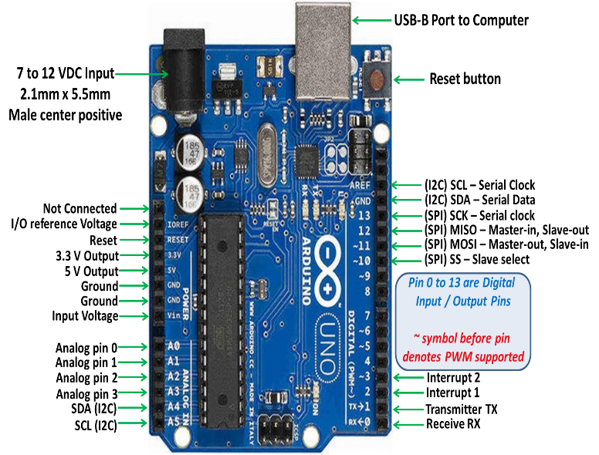

Fig 1.1: Arduino uno pin diagram

The Arduino Uno controls the wheelchair by managing power and communication with various components. It supplies 3.3V to the nRF24L01+ module through the VCC pin and shares a common ground via the GND pin. It uses CE and CSN pins to enable and select the nRF24L01+ for communication, with MOSI and MISO pins handling data transfer and SCK providing the clock signal.

For motor control, the Arduino adjusts the speed using PWM signals sent to the Enable A and Enable B pins of the L298N Motor Driver. It manages motor direction through input pins connected to the motor driver, allowing precise control of the wheelchair’s movement based on commands received from the nRF24L01+ module.

L298N Motor Driver Module:

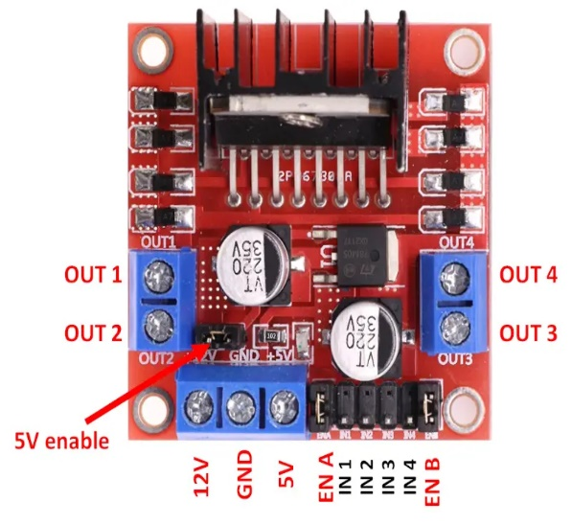

Fig 1.2: L298N pin diagram

The L298N Motor Driver regulates the wheelchair’s motors through specific pin connections. The ENB (Enable B) pin connects to D3 on the Arduino Uno to control the speed of the right motor, while the ENA (Enable A) pin, connected to D5 on the Arduino Uno, manages the speed of the left motor. The IN1 (Input 1) and IN2 (Input 2) pins, linked to D2 and D4 on the Arduino Uno, direct the rotation of the right motor. The IN3 (Input 3) and IN4 (Input 4) pins, connected to D7 and D6, control the left motor’s direction. The 5V pin from the Arduino provides logic power to the motor driver, and the 12V pin connects to an external power source to drive the motors. The GND (Ground) pin links to the Arduino’s ground to complete the circuit.

Arduino Nano:

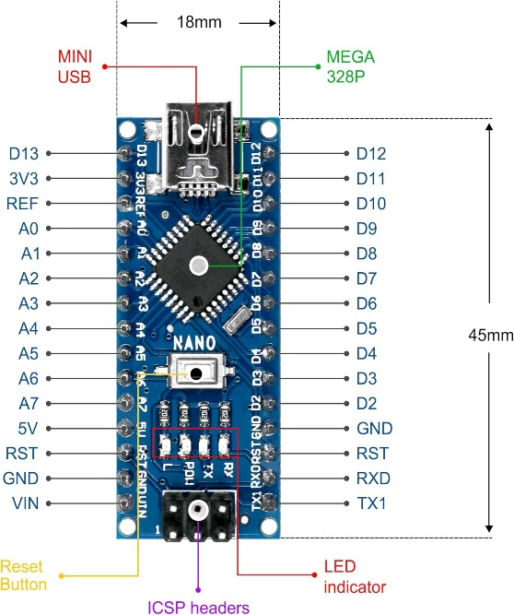

Fig 1.3: Arduino nano pin diagram

The Arduino Nano pinout diagram illustrates how the pin configuration of the Arduino Nano connects to other components in the transmitter section. Understanding the Arduino Nano’s pinout is crucial for proper connectivity with the nRF24L01+ module and the MPU6050 sensor.

The VCC (Voltage Common Collector) pin provides 3.3V power to the nRF24L01+ module, while the GND (Ground) pin establishes a common ground connection with both the nRF24L01+ and MPU6050 modules. The D9 (Digital Pin 9) connects to the CE (Chip Enable) pin on the nRF24L01+, enabling the module for both transmission and reception. The D10 (Digital Pin 10) connects to the CSN (Chip Select Not) pin on the nRF24L01+, allowing the module to be selected for communication. The D11 (Digital Pin 11) connects to the MOSI (Master Out Slave In) pin on the nRF24L01+, facilitating data transfer from the Arduino to the module, while D12 (Digital Pin 12) is linked to the MISO (Master In Slave Out) pin for receiving data from the module. The D13 (Digital Pin 13) provides the clock signal for SPI communication by connecting to the SCK (Serial Clock) pin on the nRF24L01+.

For interfacing with the MPU6050, the A4 (Analog Pin 4) connects to the SDA (Serial Data) pin, and A5 (Analog Pin 5) connects to the SCL (Serial Clock) pin, both of which are used for I2C communication.

MPU6050 Accelerometer and Gyroscope Module:

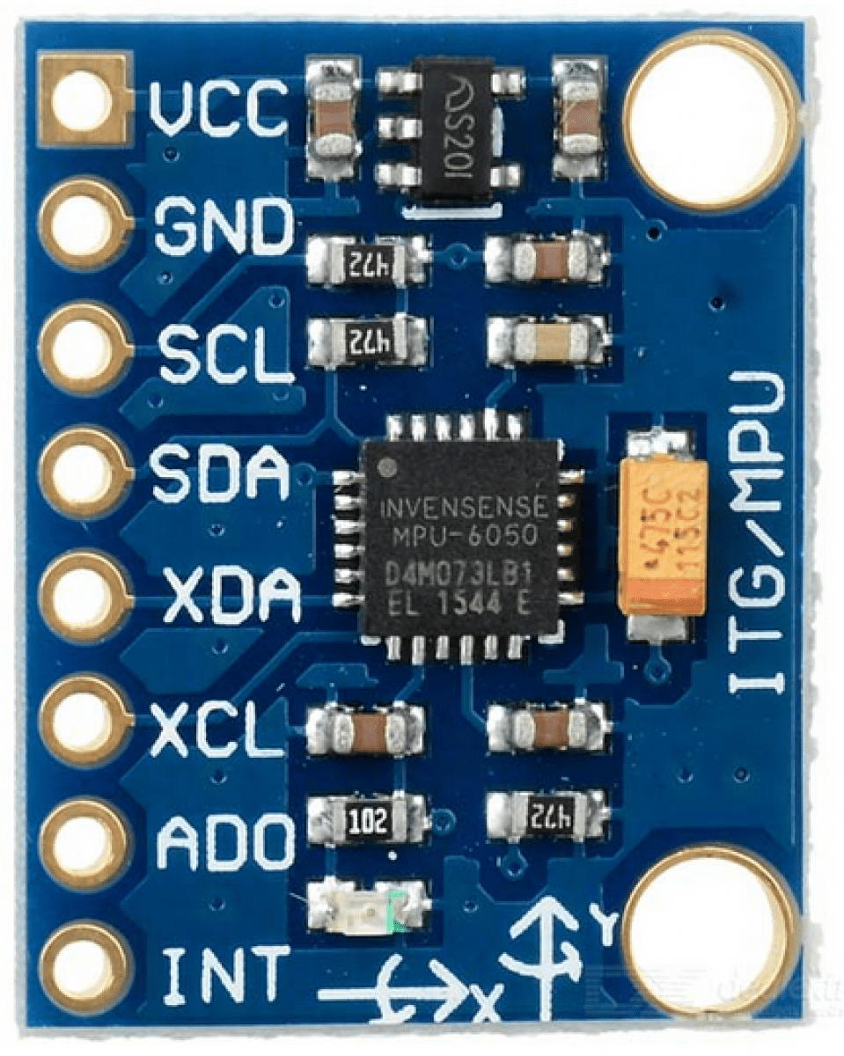

Fig 1.3: MPU6050 pin diagram

The MPU6050 pinout diagram illustrates how to connect the accelerometer and gyroscope sensor to the Arduino Nano. The MPU6050 sensor, used for motion detection, interfaces with the Arduino Nano through several key pins. The VCC (Voltage Common Collector) pin connects to the 5V output of the Arduino Nano to provide power to the sensor. The GND (Ground) pin establishes a common ground connection with the Arduino Nano for electrical reference. For communication, the SDA (Serial Data) pin connects to A4 on the Arduino Nano, managing I2C data transfer, while the SCL (Serial Clock) pin connects to A5 on the Arduino Nano, providing the clock signal needed for I2C communication.

Nrf24l01 Transmitter Receiver Module:

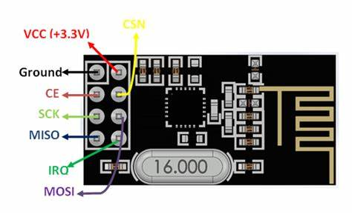

Fig 1.4: Nrf24l01 Pin diagram

The nRF24L01+ module is crucial for wireless communication with the Arduino Nano and connects through several key pins. The VCC (Voltage Common Collector) pin receives 3.3V power from the Arduino Nano’s 3.3V output. The GND (Ground) pin establishes a common ground connection with the Arduino Nano. The CE (Chip Enable) pin, connected to D9 on the Arduino Nano, activates the module for data transmission and reception. The CSN (Chip Select Not) pin, linked to D10 on the Arduino Nano, allows the Arduino to select the module for communication. The SCK (Serial Clock) pin, connected to D13 on the Arduino Nano, provides the clock signal needed for SPI communication. The MOSI (Master Out Slave In) pin, linked to D11 on the Arduino Nano, sends data from the Arduino to the module, while the MISO (Master In Slave Out) pin, connected to D12 on the Arduino Nano, receives data from the module

3.2. SCHEMATIC DIAGRAMS

The hand gesture-controlled wheelchair system is divided into two main sections: the transmitter and the receiver. The transmitter is responsible for capturing hand gestures and transmitting the corresponding data wirelessly to the receiver, which controls the movement of the wheelchair.

Transmitter Section:

The transmitter section is built around an Arduino Nano, which interfaces with an MPU6050 accelerometer and gyroscope module to detect hand gestures. The MPU6050 is connected to the Arduino Nano via I2C communication, with the SCL and SDA pins of the MPU6050 connected to the A5 and A4 pins of the Arduino Nano, respectively. The MPU6050 is powered by the 5V and GND pins of the Arduino Nano. The accelerometer and gyroscope data obtained from the MPU6050 is used to determine the direction and intensity of the hand movements, which are then processed and mapped to control signals for the wheelchair.

For wireless communication, an NRF24L01+ transceiver module is connected to the Arduino Nano. The module's VCC pin is connected to the 3.3V output of the Arduino Nano, while its GND pin is connected to the common ground. The CE and CSN pins are connected to digital pins D9 and D10, respectively, while the SCK, MOSI, and MISO pins are connected to D13, D11, and D12 on the Arduino Nano. The NRF24L01+ module transmits the processed data from the MPU6050 to the receiver module attached to the wheelchair.

The Arduino Nano itself is powered by Li-ion batteries connected to the VIN and GND pins. These batteries provide a stable power supply to the transmitter circuit, ensuring reliable operation during movement.

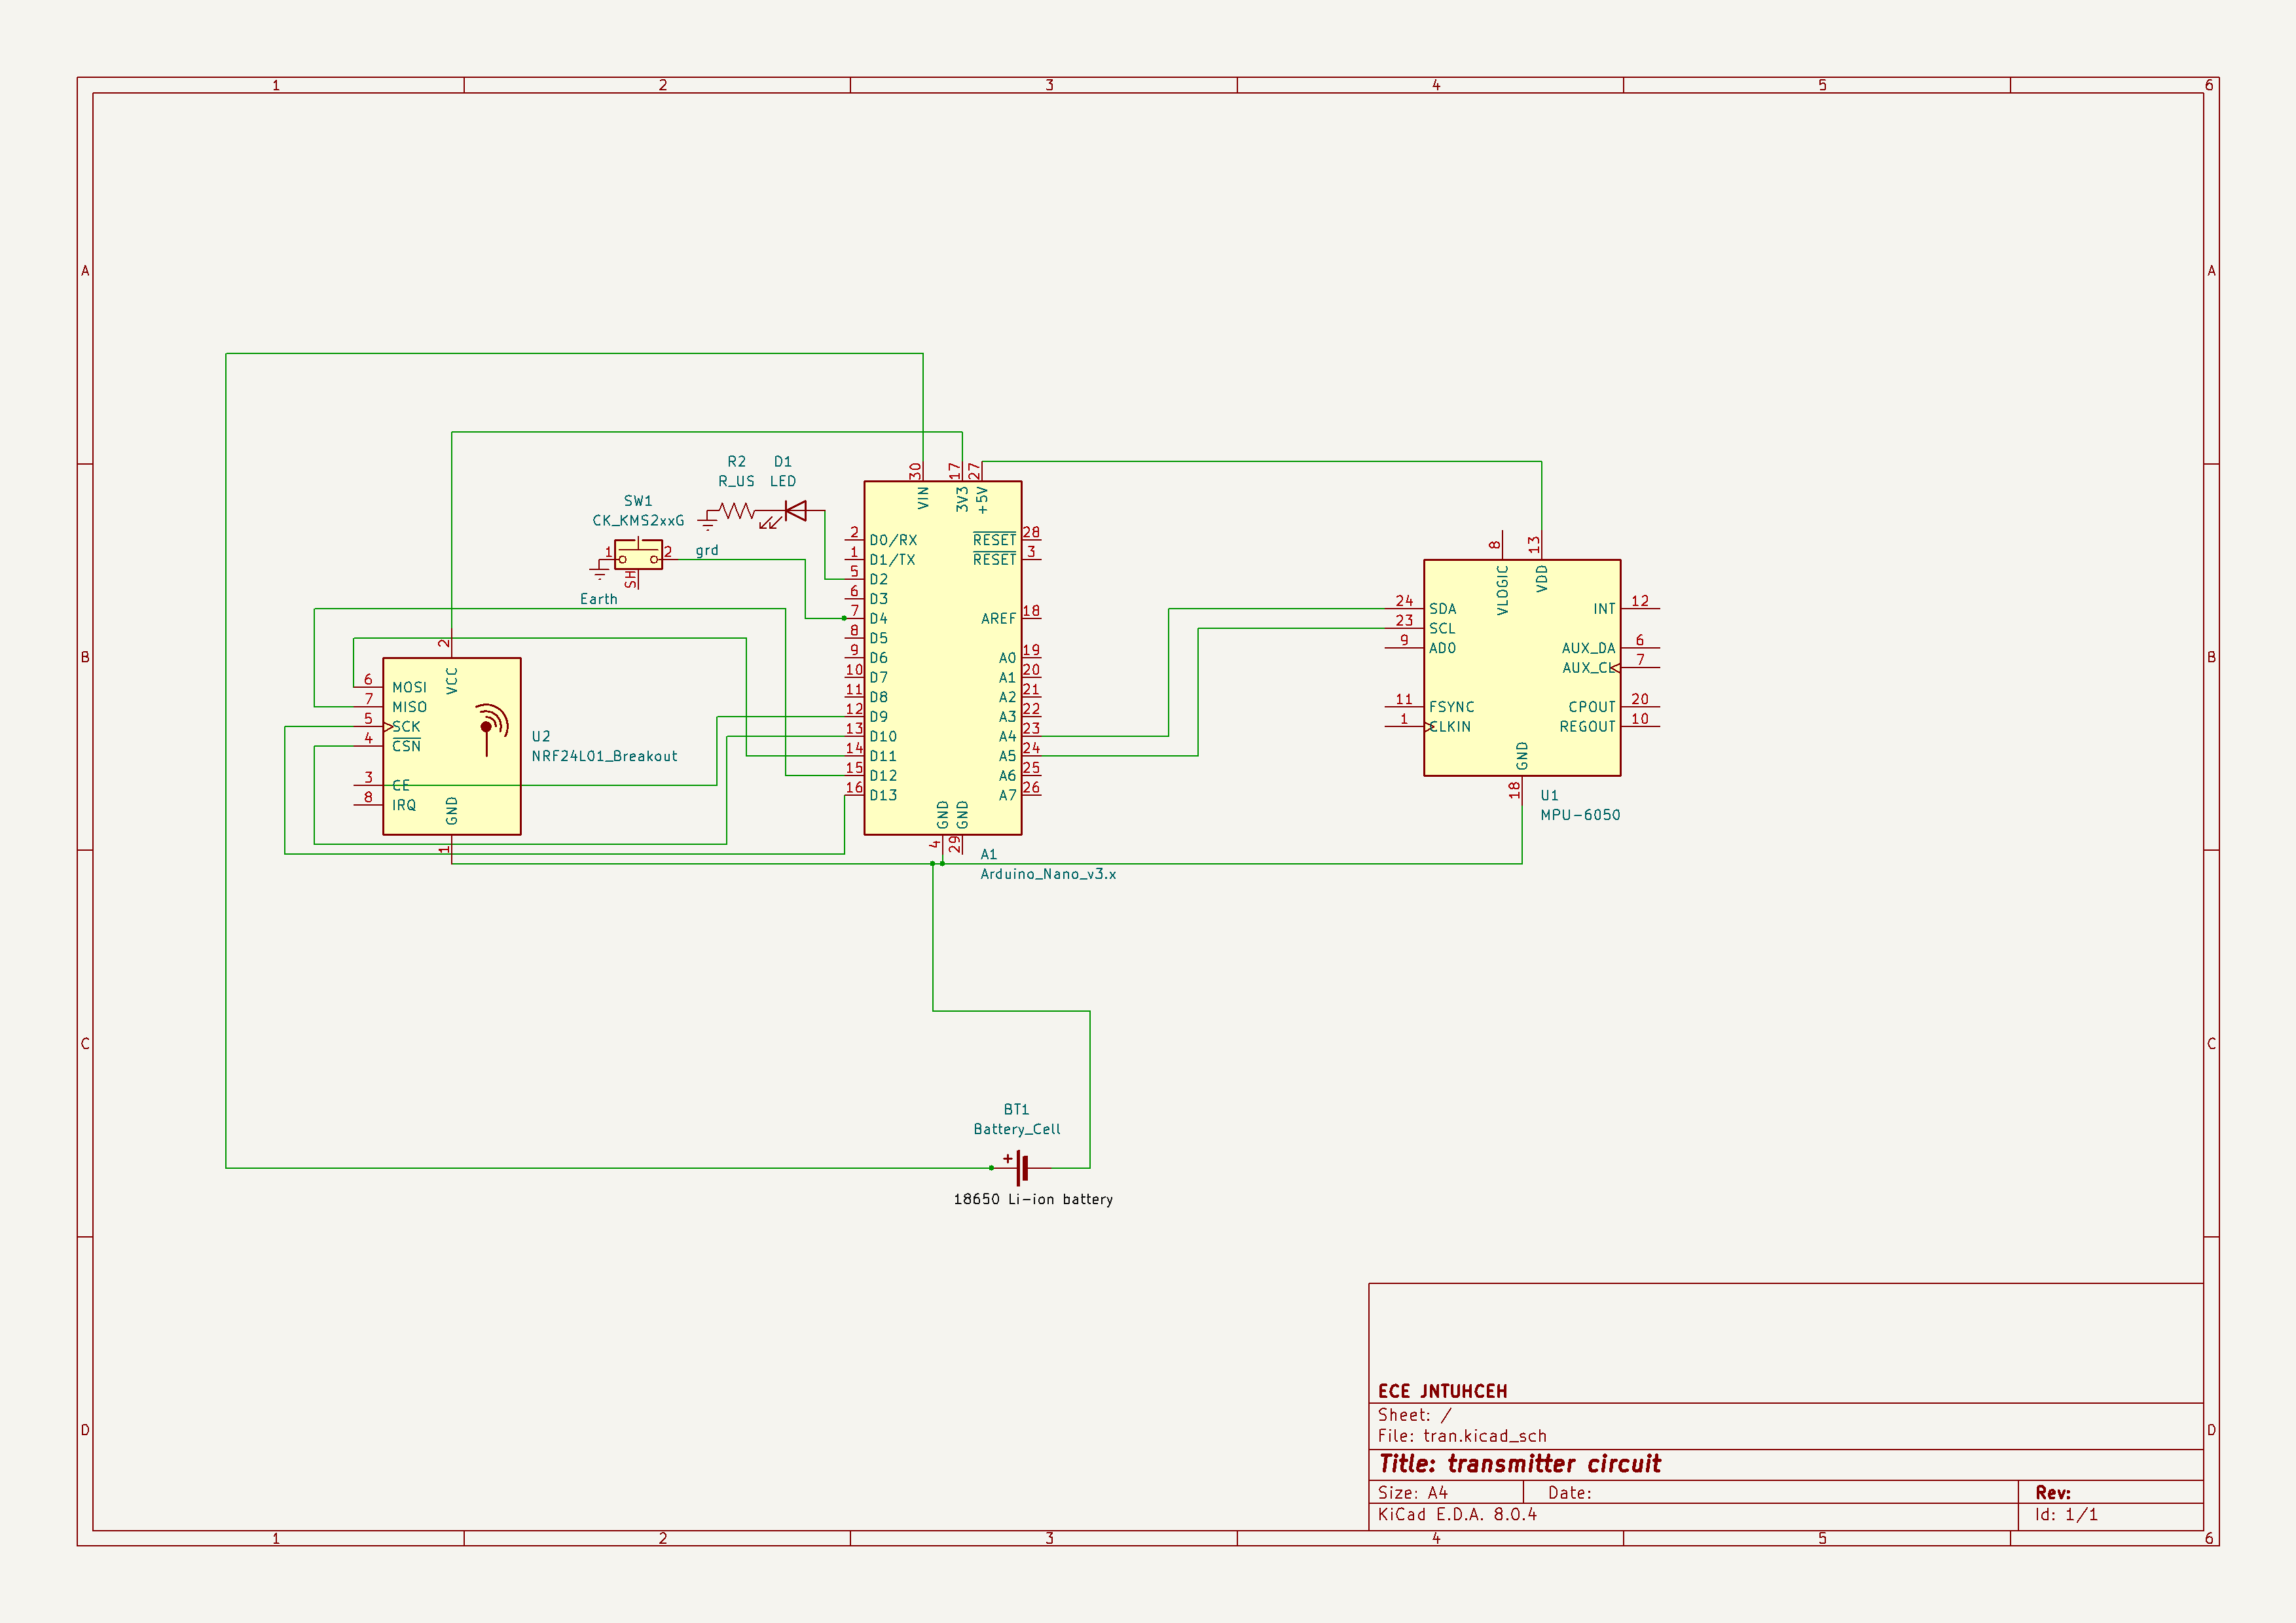

Fig 2.1 : schematic diagram of transmitter

Receiver Section:

The receiver section is built around an Arduino Uno, which interfaces with an NRF24L01+ transceiver module to receive the data sent by the transmitter. The connections between the NRF24L01+ module and the Arduino Uno mirror those in the transmitter section, with the VCC, GND, CE, CSN, SCK, MOSI, and MISO pins connected to the corresponding pins on the Arduino Uno.

The Arduino Uno controls the wheelchair motors via an L298N motor driver module. The motor driver’s ENA and ENB pins, which control the speed of the left and right motors, are connected to PWM-capable pins D5 and D3 on the Arduino Uno. The IN1 and IN2 pins, which control the direction of the right motor, are connected to D2 and D4, while the IN3 and IN4 pins, which control the left motor, areonected to D7 and D6. The L298N motor driver is powered by an external Li-ion battery pack connected to the 12V and GND terminals of the motor driver. The 5V output of the L298N is connected to the 5V pin of the Arduino Uno to provide logic power.

The receiver section processes the data received from the transmitter and translates it into motor control signals, effectively allowing the wheelchair to move in the desired direction based on the user’s hand gestures. This setup ensures seamless communication and precise control over the wheelchair’s movements, providing an intuitive and responsive user experience.

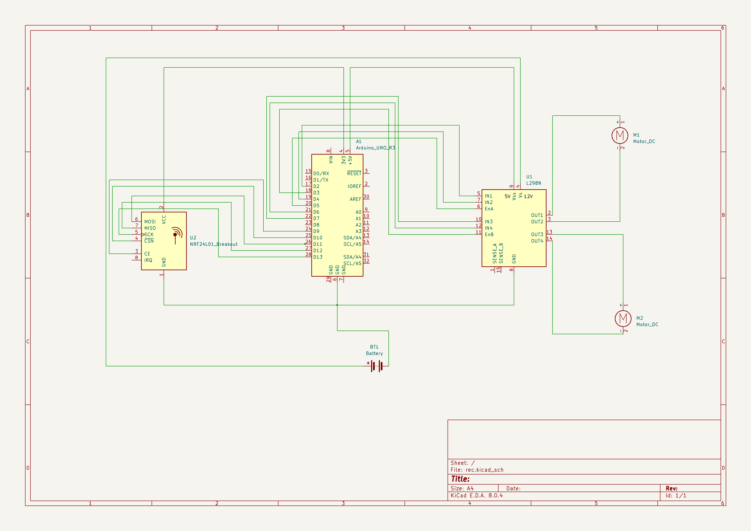

Fig 2.2: schematic diagram of receiver

3.3. SOFTWARE IMPLEMENTATION

Transmitter Section:

The software implementation for the hand gesture-controlled wheelchair transmitter involves programming the Arduino Nano to read data from the MPU6050 sensor, process this data, and transmit it wirelessly using the NRF24L01+ module. The code is divided into several key sections, each responsible for specific tasks.

1.Importing Libraries

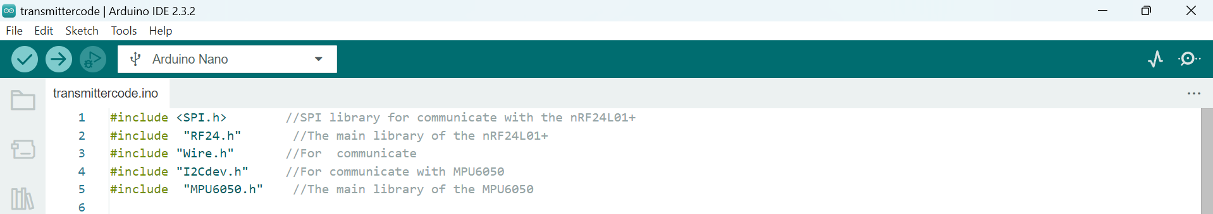

Fig 3.1 : code part 1

This section imports the necessary libraries for the project. The SPI.h library is used for SPI communication, which is required for the NRF24L01+ module. The RF24.h library is the main library for interfacing with the NRF24L01+ transceiver. The Wire.h library facilitates I2C communication, which is used to interface with the MPU6050 sensor. The I2Cdev.h and MPU6050.h libraries provide the necessary functions to interact with and retrieve data from the MPU6050.

2. Initializing Objects and Variables

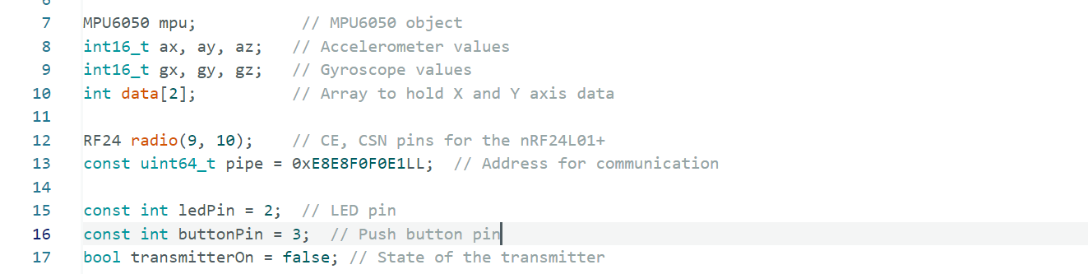

Fig 3.2 :code part 2

In this section, objects and variables are initialized. The MPU6050 mpu creates an object represents the to interact with the MPU6050 sensor. The int16_t variables ax, ay, az, gx, gy, and gz are used to storewill hold the raw accelerometer and gyroscope datareadings from the MPU6050. The data[2] array will store processed accelerometer data to be transmitted wirelessly. The sensor. The int data[2] array stores the X and Y axis values after they are processed and mapped. RF24 radio(9, 10) object initializes the NRF24L01radio communication with the nRF24L01+ module, with the CE and CSN pins connected tousing digital pins 9 for CE (Chip Enable) and 10 of the Arduino Nano. The pipe variable stores the address of the receiver module, ensuring that the data is sent to the correct destination.

for CSN (Chip Select Not). The constant uint64_t pipe sets the communication address for the radio module. The const int ledPin = 2 and const int buttonPin = 3 define which pins are used for the LED and push button, respectively. bool transmitterOn keeps track of whether the transmitter is active or not.

3. Setup Function

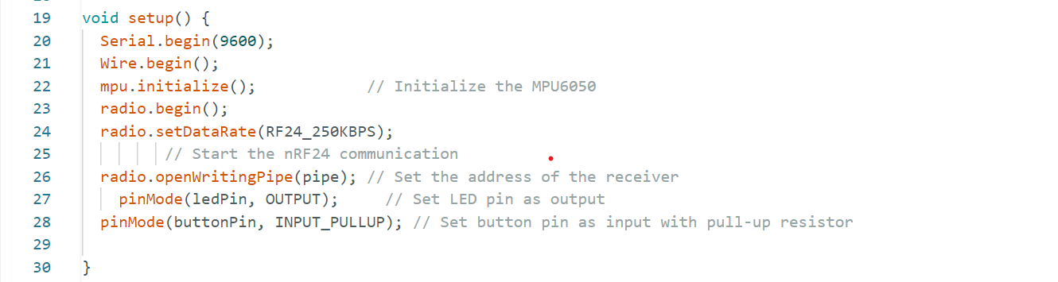

Fig 3.3: code part 3

The setup function initializes the various components. The Serial.begin(9600) command starts the serial communication at a baud rate of 9600, useful for debugging purposes. The Wire.begin() command initializes the I2C communication, allowing the Arduino to communicate with the MPU6050 sensor. The mpu.initialize() function initializes the MPU6050 sensor, preparing it to read accelerometer and gyroscope data. The radio.begin() function initializes the NRF24L01+ module, and radio.openWritingPipe(pipe) sets up the communication channel by specifying the address of the receiver.

In the setup function, the system is initialized. Serial.begin(9600) starts serial communication at 9600 baud rate for debugging. Wire.begin() initializes I2C communication, enabling interaction with I2C devices. Mpu.initialize() sets up the MPU6050 sensor for operation. Radio.begin() initializes the radio module. Radio.setDataRate(RF24_250KBPS) sets the data rate to 250 kbps for communication. Radio.openWritingPipe(pipe) specifies the address for sending data, ensuring that the radio module knows where to send the information. pinMode(ledPin, OUTPUT) and pinMode(buttonPin, INPUT_PULLUP) configure the LED pin as an output and the button pin as an input with an internal pull-up resistor, respectively.

4. Loop Function

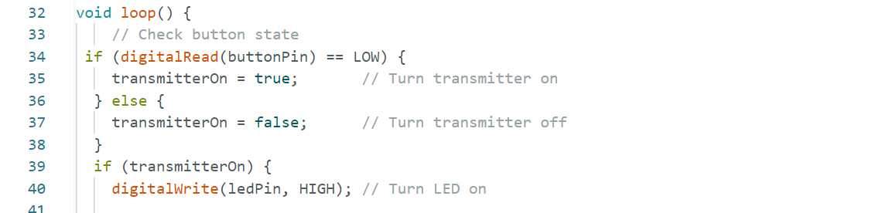

Fig 3.4: code part 4

The loop function continuously executes to manage the data transmission based on the button state. It first checks the button state using digitalRead(buttonPin). If the button is pressed (LOW), transmitterOn is set to true, indicating that data transmission should occur. The LED is turned on with digitalWrite(ledPin, HIGH) to show that the transmitter is active.

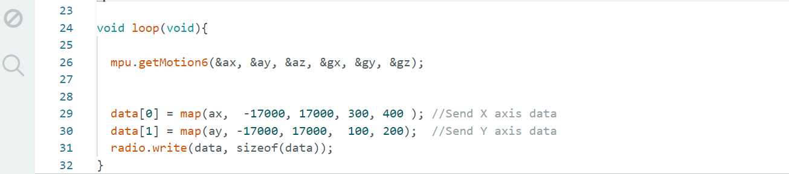

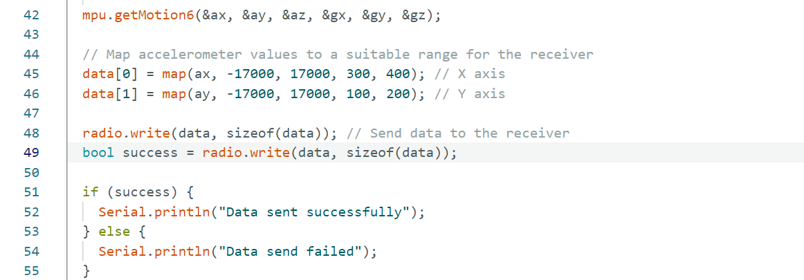

Fig 3.5: code part 5

The mpu.getMotion6(&ax, &ay, &az, &gx, &gy, &gz) function reads data from the MPU6050 sensor, capturing acceleration and gyroscope values. The map function then scales these sensor values to a suitable range for the receiver. radio.write(data, sizeof(data)) sends the processed data to the receiver. The function checks if the data was sent successfully and prints a message to the serial monitor accordingly.

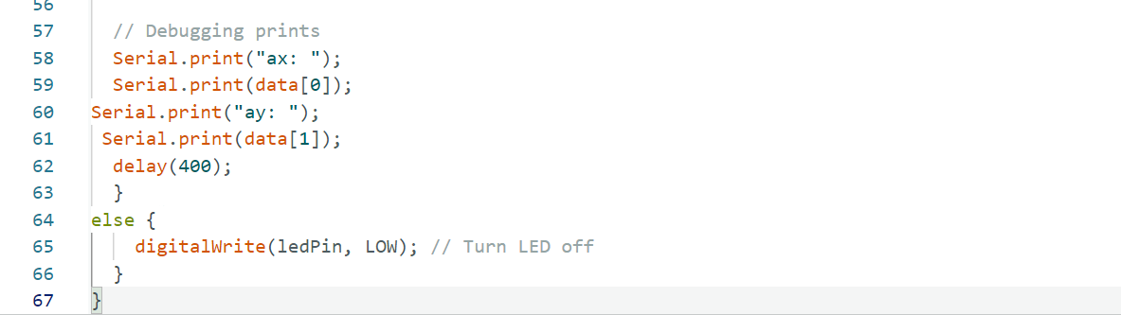

Fig 3.6: code part 6

The loop function continuously reads data from the MPU6050 and transmits it using the NRF24L01+ module. The mpu.getMotion6(&ax, &ay, &az, &gx, &gy, &gz) function retrieves the raw accelerometer and gyroscope data from the MPU6050 and stores it in the respective variables. The map function scales the accelerometer data (ax and ay) to a specific range that corresponds to the control signals for the wheelchair. The data[0] array stores the mapped X-axis data, and data[1] stores the mapped Y-axis data. Finally, radio.write(data, sizeof(data)) transmits the data array to the receiver module.

Raw data values are also printed for debugging purposes. A delay(400) ensures that data is sent every 0.4 seconds. If the button is not pressed, transmitterOn is set to false, and the LED is turned off (digitalWrite(ledPin, LOW)), indicating that the transmitter is inactive.

The software implementation starts by importing the necessary libraries for communication with the NRF24L01+ module and the MPU6050 sensor. The setup function initializes the MPU6050 and NRF24L01+ modules, establishing the communication channels. The loop function continuously reads the accelerometer data, scales it, and transmits it wirelessly to the receiver module, enabling real-time control of the wheelchair based on hand gestures. This setup allows for efficient and responsive gesture-based control, making the wheelchair easy to operate for users with limited mobility.

Receiver Section:

The receiver section of the hand gesture-controlled wheelchair project involves programming the Arduino Uno to receive data wirelessly from the transmitter, interpret this data, and control the motors of the wheelchair accordingly.

Importing Libraries

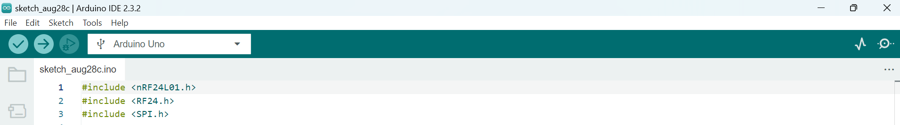

Fig 4.1 : code part 1

This section includes the necessary libraries for the receiver code. The nRF24L01.h, printf.h, RF24.h, and RF24_config.h libraries are specific to the NRF24L01+ module, enabling wireless communication. The SPI.h library is required for SPI communication, which the NRF24L01+ module relies on.

Initializing Pins and Variables

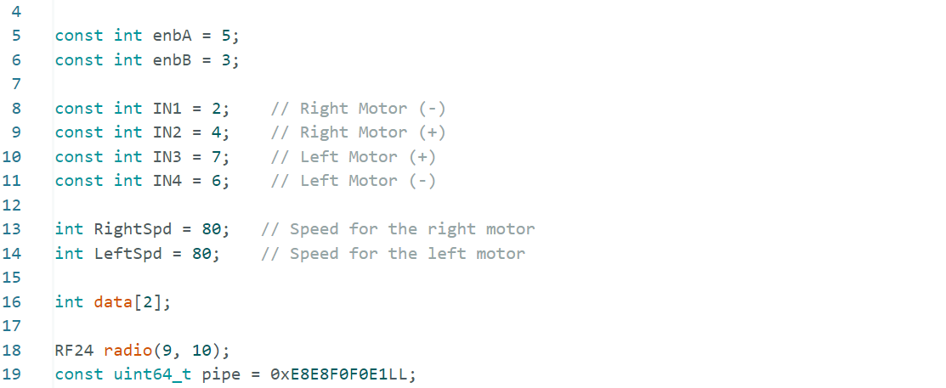

Fig 4.2 : code part 2

This section defines the motor control pins and initializes variables. enbA and enbB control the speed of the right and left motors, respectively. IN1, IN2, IN3, and IN4 control the direction of the motors. RightSpd and LeftSpd are variables for setting the speed of the motors, while the data[2] array stores the received data from the transmitter. The RF24 radio(9,10) object initializes the NRF24L01+ module, with CE and CSN connected to pins 9 and 10 of the Arduino Uno. The pipe variable stores the address of the transmitter module.

3. Setup Function

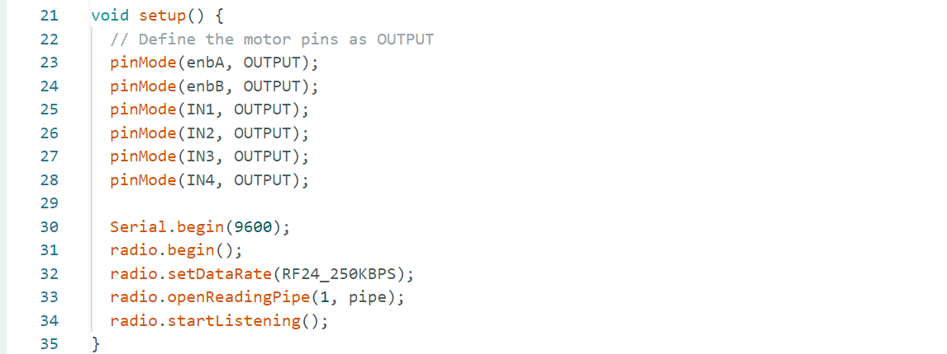

Fig 4.3 :code part 3

The setup function initializes the motor control pins and sets them as outputs. pinMode is used to configure the pins for output control of the motors. The Serial.begin(9600) command initializes serial communication for debugging. The radio.begin() function initializes the NRF24L01+ module, radio.openReadingPipe(1, pipe) opens a communication channel to receive data, and radio.startListening() starts the module in listening mode to continuously receive data from the transmitter.

Loop Function

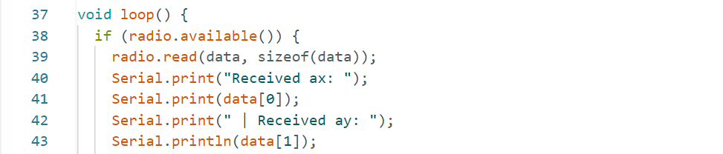

Fig 4.4: code part 4

The loop function begins by checking if the nRF24L01+ module has any data available for reading. This is done using radio.available(). If data is available, it is read into the data array using radio.read(data, sizeof(data)). The accelerometer values are then printed to the serial monitor with Serial.print and Serial.println for debugging purposes. This allows you to see the raw data that is being received and to verify that the sensor data is being read correctly.

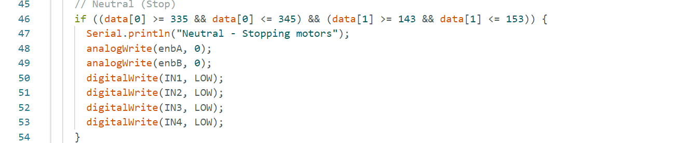

Fig 4.5: code part 5

The next part of the code interprets the received data to determine if the wheelchair should stop. It checks if the accelerometer values fall within a specific range that represents a neutral or stop position. If the condition (data[0] >= 335 && data[0] <= 345) && (data[1] >= 143 && data[1] <= 153) is met, it means the system should stop. The code sets the motor speed to zero by writing 0 to the enable pins (enbA and enbB), and all direction pins (IN1, IN2, IN3, IN4) are set to LOW to ensure the motors are not moving.

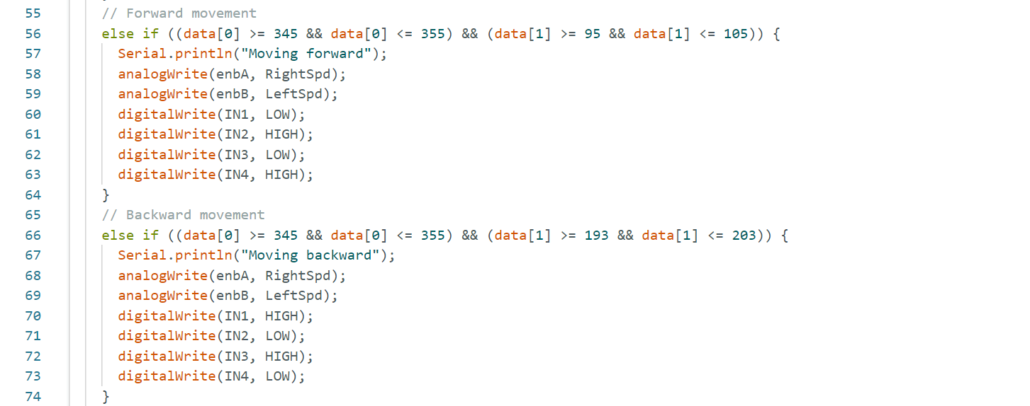

Fig 4.6: code part 6

The loop function then checks for specific movement commands. For forward movement, it verifies if the accelerometer data indicates a forward direction within the range (data[0] >= 345 && data[0] <= 355) && (data[1] >= 95 && data[1] <= 105). If so, it sets the appropriate motor speeds and direction pins to move the wheelchair forward. Similarly, for backward movement, it checks if the data indicates a backward direction within the range (data[0] >= 345 && data[0] <= 355) && (data[1] >= 193 && data[1] <= 203), setting the motors to move in reverse. Turning left or right is handled by checking data ranges for turning commands and adjusting the motor speeds and directions accordingly.

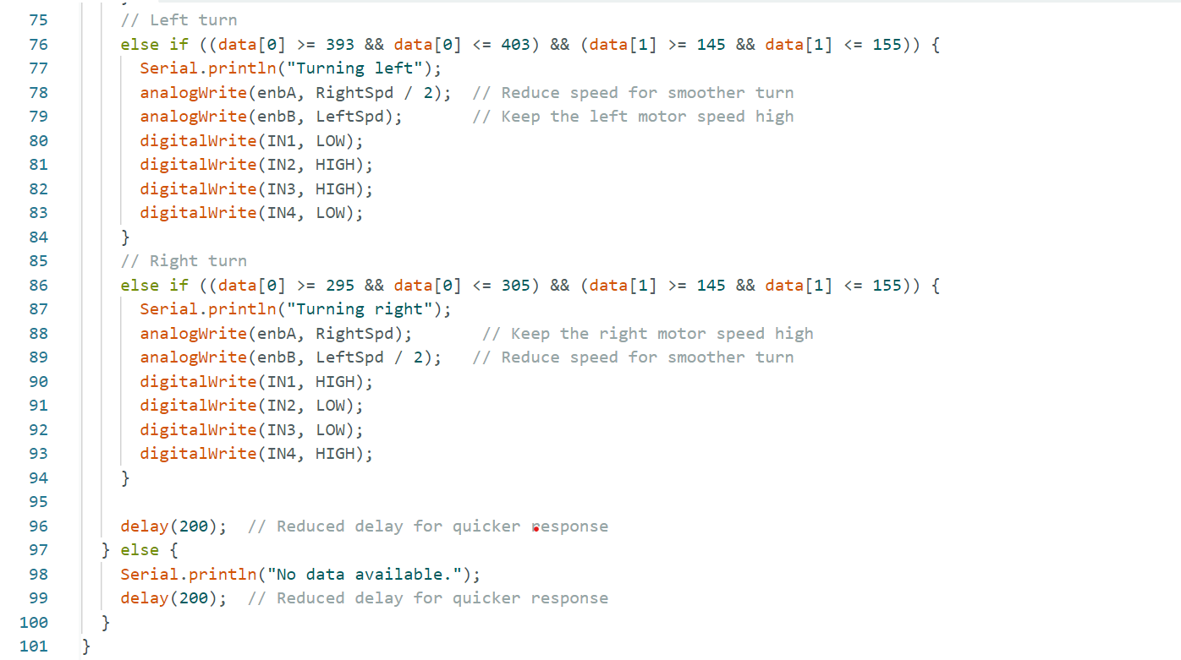

Fig 4.7: code part 7

In the receiver section, the Arduino Uno is programmed to control the wheelchair's motors based on the data received from the transmitter. The program begins by initializing the motor control pins and setting up the NRF24L01+ module to listen for incoming data. The loop function continuously checks for available data and controls the motors to move the wheelchair forward, backward, left, right, or stop based on the received data. This setup enables the wheelchair to respond accurately and promptly to hand gestures, providing the user with a smooth and intuitive control experience.

Finally, if no data is available from the module, a message "No data available." is printed to the serial monitor. The function then waits for 4000 milliseconds before checking for new data again. This delay helps manage the frequency of data checks and ensures that the system does not continuously poll the sensor, which could be inefficient or unnecessary. The delay period can be adjusted based on the desired responsiveness of the wheelchair.

Each section of the loop function is responsible for handling different aspects of the wheelchair’s control based on the received data, from reading and interpreting sensor data to managing movement commands and handling delays.

4.WORKING

The hand gesture-controlled wheelchair operates through a wireless communication system between a transmitter and a receiver. The user wears the transmitter, which captures hand gestures using a motion sensor. The processed gesture data is transmitted wirelessly to the receiver mounted on the wheelchair. The receiver interprets this data to control the wheelchair’s movements. Based on the received commands, the wheelchair’s motor driver adjusts the speed and direction of the motors, enabling the wheelchair to move forward, backward, or turn. When no significant movement is detected, the system commands the wheelchair to stop. The entire system is powered by a rechargeable battery, ensuring efficient operation.

Transmitter section:

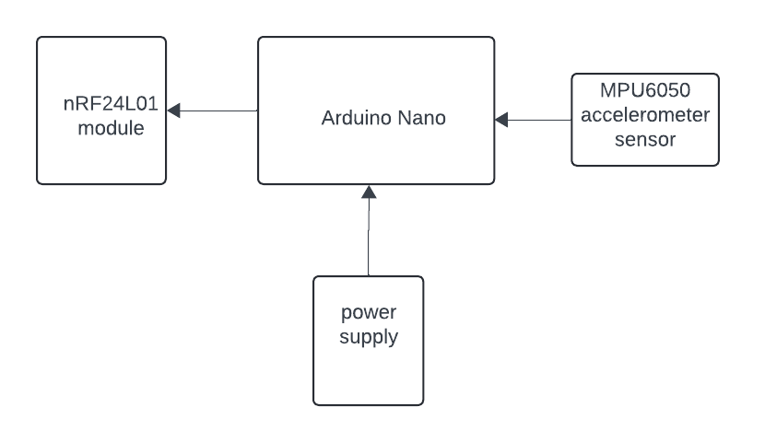

Fig 5.1: block diagram of transmitter

The above block diagram illustrates the transmitter module of the hand gesture-controlled wheelchair. At the core of this module is the MPU6050 sensor, which measures the tilt and acceleration of the user's hand along the X and Y axes. This sensor provides the necessary data to determine the direction of movement. The data from the MPU6050 is processed by the Arduino Nano, which interprets these sensor readings and converts them into control signals. These processed signals are then transmitted wirelessly to the receiver module using the NRF24L01+ module. The NRF24L01+ ensures that the data is sent securely and accurately to the receiver.

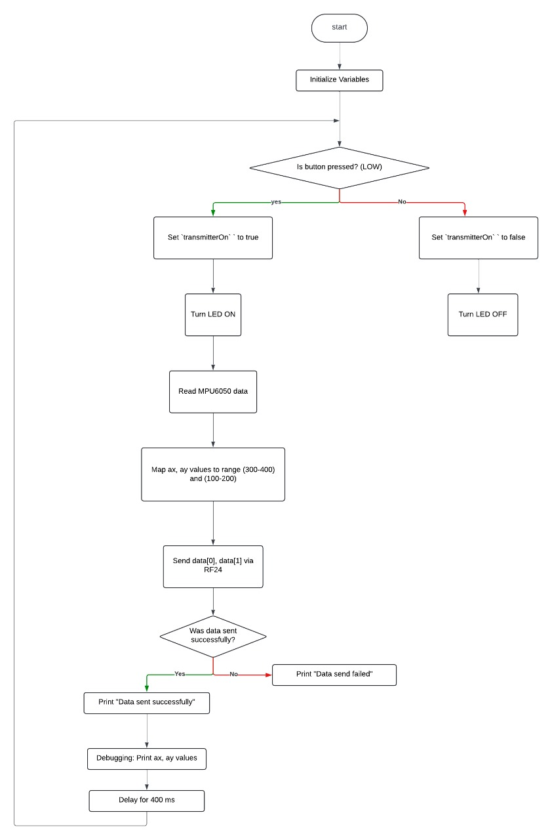

Fig 5.2: flowchart of transmission section

The transmitter system begins by powering on and initializing all necessary components, including the MPU6050 sensor for reading accelerometer and gyroscope data, and the nRF24L01+ module for wireless communication. The LED and push button are also set up during initialization. The system continuously monitors the state of the push button. If the button is pressed, the transmitter is activated, turning on the LED to indicate power. The system then reads the accelerometer data from the MPU6050, maps the raw data to a suitable range, and sends this data wirelessly to the receiver using the nRF24L01+ module. If the button is not pressed, the transmitter remains off, and the LED stays off.

Receiver section:

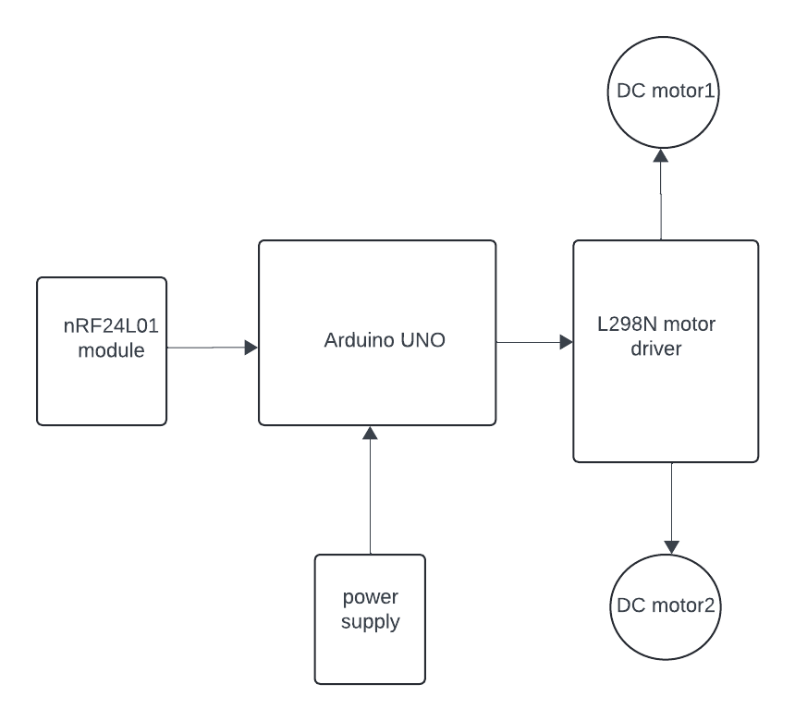

Fig 5.3: block diagram of receiver

The second block diagram represents the receiver module, which is responsible for executing the commands received from the transmitter. The NRF24L01+ module on the receiver side captures the transmitted control signals and forwards them to the Arduino Uno. The Arduino Uno processes these commands and directs the L298N motor driver accordingly. The motor driver controls the wheelchair’s motors based on the commands from the Arduino Uno, adjusting their speed and direction to achieve the desired movement. This module allows the wheelchair to move forward, backward, or turn, depending on the received instructions.

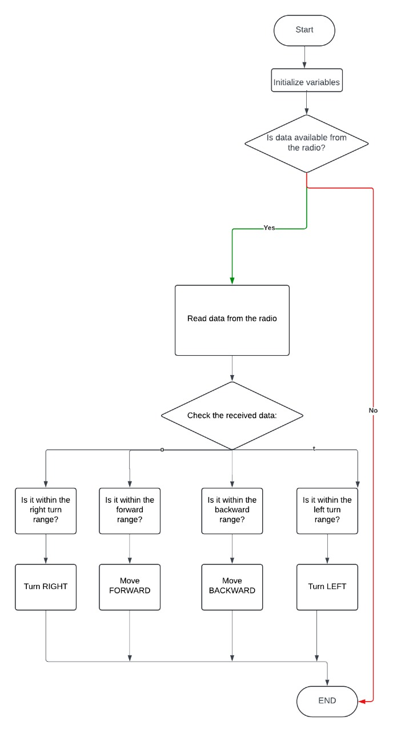

Fig 5.4: flow chart of receiver section

The receiver part begins by initializing the nRF24L01+ module for communication and setting up the motor driver pins to control the wheelchair's movement. It continuously listens for incoming data from the transmitter. When data is received, it checks the mapped accelerometer values for specific ranges that correspond to different gestures (e.g., forward, backward, left, right, or stop). Based on the received values, the system determines the appropriate movement direction for the wheelchair and activates the motors accordingly. If no data is received, the system remains in a neutral state, keeping the motors off to stop the wheelchair.

Action | Data[0] | Data[1] | Left motor | Right motor
Neutral /stop | 335-445 | 143-153 | Low | Low
Forward | 345-355 | 95-105 | High | High
Backward | 345-355 | 193-203 | High | High
Left | 393-403 | 145-155 | High | Low
Right | 295-305 | 145-155 | Low | High

Fig 6.1 : motion detection data table

The above table indicates the observed motions with their sensor datas along with the motion of each motor. In the hand gesture-controlled wheelchair system, sensor data from the MPU6050 accelerometer and gyroscope module is used to direct the wheelchair’s movements. The data is processed by the Arduino Nano to determine the appropriate actions.

The data[0] value represents the tilt or acceleration along the X-axis. This value is used to control the forward and backward movements of the wheelchair.

The data[1] value represents the tilt or acceleration along the Y-axis and is used for turning movements.

When the data[0] value falls between 335 and 345 and data[1] is between 143 and 153, the system identifies this as a neutral or stop condition. In response, both motors are stopped with all control signals set to LOW, keeping the wheelchair stationary.

For forward movement, if data[0] ranges from 345 to 355 and data[1] is between 95 and 105, the system detects a forward tilt. This results in both the left and right motors moving forward at speeds defined by RightSpd and LeftSpd, making the wheelchair move forward.

In the case of backward movement, when data[0] is between 345 and 355 and data[1] is between 193 and 203, the system interprets this as a backward tilt. Both motors are then commanded to move backward with speeds set to RightSpd and LeftSpd, causing the wheelchair to reverse.

When data[0] is between 393 and 403 and data[1] is between 145 and 155, indicating a left tilt, the system adjusts the right motor to a lower speed (RightSpd / 2) while keeping the left motor at full speed (LeftSpd). This setup results in a left turn.

Finally, if data[0] falls between 295 and 305 and data[1] is between 145 and 155, suggesting a right tilt, the system sets the left motor to a lower speed (LeftSpd / 2) while keeping the right motor at full speed (RightSpd). This configuration causes the wheelchair to turn right.

This setup ensures that the wheelchair responds intuitively to the user's hand gestures, enabling smooth and precise control of movement and direction.

5.TESTING

Component Testing

Before system integration, each component was rigorously tested to verify its standalone functionality.

MPU6050 Sensor: The MPU6050 sensor was tested to ensure it accurately measures hand tilt and acceleration. Tests involved tilting the sensor in various directions and recording the output values. Calibration was performed to match the sensor’s readings with expected tilt angles, ensuring precise measurement.

Arduino Nano: The Arduino Nano was evaluated for its ability to read and process data from the MPU6050 sensor. Test scripts were uploaded to the Arduino to check if it correctly interpreted sensor inputs and generated appropriate control signals based on different hand gestures.

NRF24L01+ Module (Transmitter Side): The NRF24L01+ module was tested for reliable data transmission. This included checking signal strength, data integrity, and communication range. Tests ensured that the module could transmit data consistently without significant loss or interference.

NRF24L01+ Module (Receiver Side): The receiver module’s NRF24L01+ was tested to confirm its ability to accurately receive data from the transmitter module. The module was assessed for data reception accuracy and response to varying signal strengths.

Arduino Uno: The Arduino Uno was tested to verify its functionality in receiving and processing data from the NRF24L01+ module. Tests involved checking the Arduino’s ability to decode received commands and send appropriate signals to the motor driver.

L298N Motor Driver: The L298N motor driver was tested to ensure it could control the wheelchair’s motors effectively. Tests included running the motors in forward, backward, left, and right directions based on input commands, and verifying that the driver adjusted motor speed and direction accurately.

System Integration Testing

After successful component testing, the components were integrated into the full system, and comprehensive testing was performed.

Functionality Tests:

Forward and Backward Movement: The wheelchair was tested by tilting the user’s hand forward and backward. The system’s response was monitored to ensure that the wheelchair moved forward or backward smoothly and as expected.

Turning Left and Right: Turning capabilities were tested by tilting the hand left and right. The accuracy of the wheelchair’s turns was assessed, ensuring the movement matched the direction of the hand tilt.

Stopping Mechanism: The stop functionality was tested by holding the hand in a neutral position. The system’s ability to halt the wheelchair promptly was verified, ensuring it stopped completely and maintained the stop position until a new command was issued.

Performance Tests:

Range and Signal Strength: The wireless communication range was tested to determine the effective distance between the transmitter and receiver modules. Signal strength was monitored to ensure consistent performance without significant data loss.

Speed and Responsiveness: The wheelchair’s responsiveness to hand gestures was evaluated, including speed adjustments and direction changes. The performance was assessed for smoothness and accuracy in response to various gesture inputs.

OBSERVATIONS

The testing of the hand gesture-controlled wheelchair confirmed its successful operation with all components functioning as intended. The MPU6050 sensor provided accurate tilt and acceleration measurements, allowing precise interpretation of hand gestures. The Arduino Nano effectively processed these inputs, generating the correct control signals. Both NRF24L01+ modules demonstrated reliable communication, with strong signal strength and minimal data loss. The Arduino Uno accurately received and processed commands from the transmitter, and the L298N motor driver controlled the wheelchair’s motors precisely, enabling smooth forward, backward, left, and right movements. The system maintained reliable performance within the tested range, with responsive and accurate control of the wheelchair’s speed and direction. Overall, the integration of the components resulted in a functional and intuitive control system that enhances user mobility and independence, with consistent and dependable operation across various testing scenarios.

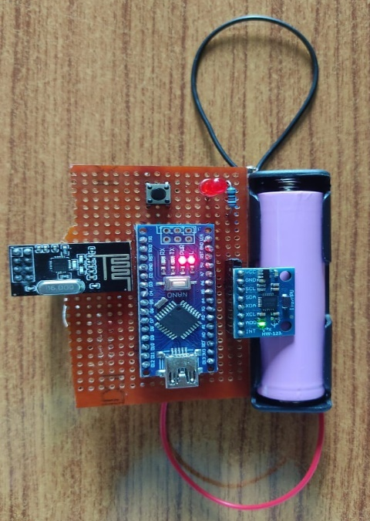

Fig 7.1 : prototype of transmitter

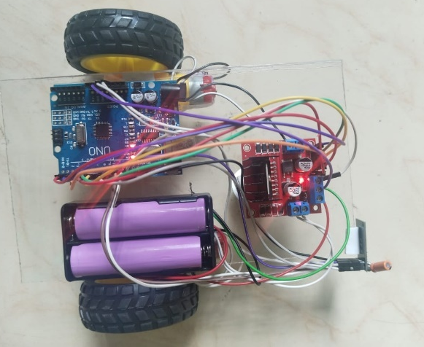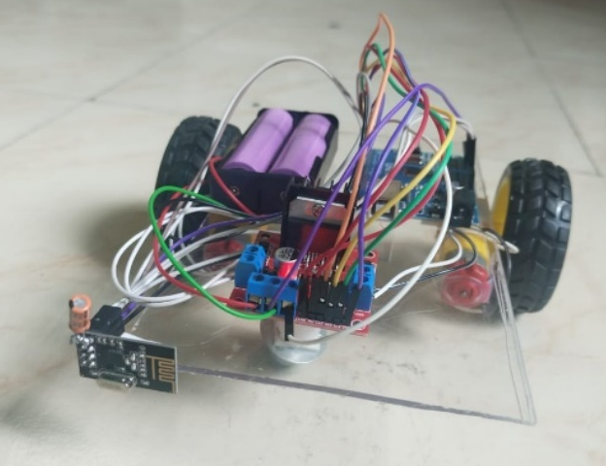

Fig 7.2(a) Fig 7.2(b)

Fig 7.2: Prototype of receiver section

6.CONCLUSION & FUTURE SCOPE

The hand gesture-controlled wheelchair project has successfully achieved its primary goal of establishing a reliable wireless connection for controlling mobility. The system has demonstrated effective translation of hand gestures into precise wheelchair movements, with accurate gesture recognition, consistent data transmission, and responsive motor control. This successful implementation underscores the project’s potential to significantly enhance user mobility and independence, providing a practical solution for individuals with limited manual dexterity or strength.

Looking ahead, there is substantial room for further development. The foundation laid by this project offers opportunities to incorporate additional features and improvements, such as advanced gesture recognition, obstacle detection, extended communication range, and enhanced user interaction. Future enhancements could focus on refining the system's performance, optimizing user experience. By exploring these possibilities, the project could evolve to offer even more sophisticated and user-friendly solutions, expanding its capabilities and applications to better support individuals with mobility challenges.

REFERENCES
- Pushpendra Jha and P. Khurana, "Hand Gesture Controlled Wheelchair," Int. J. Scientific & Technol. Res., vol. 9, pp. 243-249, 2016.
- V. Sridevi, P. Iswarya, S. Chandra, P. Podugu, and N. Suresh Kumar, "Automated Gesture Based Wireless Wheelchair Control by Means of Accelerometer," Int. J. Eng. and Adv. Technol., vol. 9, no. 2, pp. 2249-8958, 2019.
- M. I. Miftahussalam, E. S. Julian, K. Prawiroredjo, and E. Djuana, "Wheelchair Control System with Hand Movement Using Accelerometer Sensor," Microelectron. Eng., vol. 278, pp. 112018, 2023.
- P. Sujidha, Dr. R. Niraimathi, S. Chitra Devi, P. Radha, and A. Usha, "An Intelligent Control of Wheel Chair by Hand Gesture," Int. J. Adv. Res. in Sci., Commun. and Technol., vol. 2, no. 1, pp. 497, Nov. 2022. DOI: 10.48175/568.
- Prof. P. P. Chitte, Miss S. B. Khemnar, Miss A. A. Kanawade, and Miss S. B. Wakale, "A Hand Gesture Based Wheelchair for Physically Handicapped Person with Emergency Alert System," Int. Res. J. Eng. and Technol. (IRJET), vol. 3, no. 4, Apr. 2016.
- S. Sndeept and S. Supriya, "Wheel-Chair Control Using Accelerometer Based Gesture Technology," Int. J. Adv. Res. in Comput. Eng. and Technol. (IJARCET), vol. 4, no. 5, pp. 123-130, May 2015.

BIBILOGRAPHY

- Arduino. "Arduino IDE." Arduino.cc
https://www.arduino.cc/en/software
- Arduino. "RF24 Library for Arduino." Arduino.cc https://www.arduino.cc/reference/en/libraries/rf24/
- Nordic Semiconductor. "nRF24L01+ Single Chip 2.4GHz Transceiver - Product Specification." Nordic Semiconductor, 2010. https://www.nordicsemi.com/Products/Low-power-short-range-wireless/nRF24-series/nRF24L01P
- InvenSense. "MPU-6000 and MPU-6050 Product Specification Revision 3.4." InvenSense, 2013.
https://invensense.tdk.com/products/motion-tracking/6-axis/mpu-6050/
- "How to Interface MPU6050 with Arduino." Electronics Hub, 2022. https://www.electronicshub.org/interfacing-mpu6050-accelerometer-gyro-sensor-arduino/
- "Getting Started with nRF24L01 Wireless Transceiver Module." Last Minute Engineers
https://lastminuteengineers.com/nrf24l01-arduino-wireless-communication-tutorial/

